Social Media APIs

📱 What Are Social Media APIs?
# Source: Chatgpt (GPT-5-Mini) at [1/19/2026]
Social Media APIs are web-based interfaces provided by platforms like Facebook, Twitter, Instagram, YouTube, etc., that allow apps or websites to interact with social media content and features — such as posting content, reading user data, analyzing trends, or managing advertising.

✅ What Social Media APIs Can Do
# Source: Chatgpt (GPT-5-Mini) at [1/19/2026]
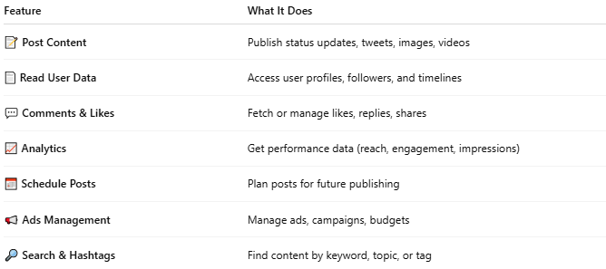

Feature | What It Does
📝 Post Content | Publish status updates, tweets, images, videos
📄 Read User Data | Access user profiles, followers, and timelines
💬 Comments & Likes | Fetch or manage likes, replies, shares
📈 Analytics | Get performance data (reach, engagement, impressions)
📅 Schedule Posts | Plan posts for future publishing
📢 Ads Management | Manage ads, campaigns, budgets
🔎 Search & Hashtags | Find content by keyword, topic, or tag

🧩 Popular Social Media APIs
# Source: Chatgpt (GPT-5-Mini) at [1/19/2026]
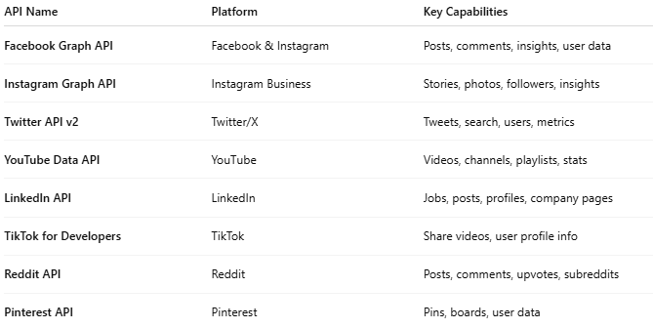

API Name | Platform | Key Capabilities
Facebook Graph API | Facebook & Instagram | Posts, comments, insights, user data
Instagram Graph API | Instagram Business | Stories, photos, followers, insights
Twitter API v2 | Twitter/X | Tweets, search, users, metrics
YouTube Data API | YouTube | Videos, channels, playlists, stats
LinkedIn API | LinkedIn | Jobs, posts, profiles, company pages
TikTok for Developers | TikTok | Share videos, user profile info
Reddit API | Reddit | Posts, comments, upvotes, subreddits
Pinterest API | Pinterest | Pins, boards, user data

📤 Example: Twitter API (Get Tweets)
# Source: Chatgpt (GPT-5-Mini) at [1/19/2026]
Request:
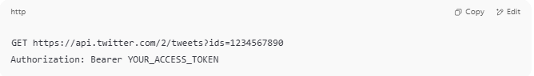
GET https://api.twitter.com/2/tweets?ids=1234567890
Authorization: Bearer YOUR_ACCESS_TOKEN

Response:
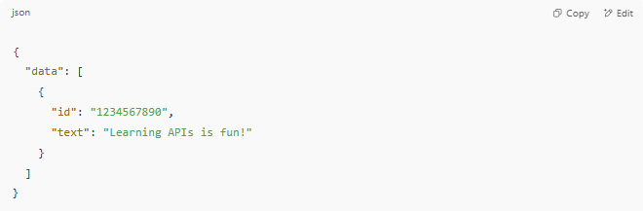
{
"data": [
{
"id": "1234567890",
"text": "Learning APIs is fun!"
}
]
}

🔐 Authentication Types
# Source: Chatgpt (GPT-5-Mini) at [1/19/2026]
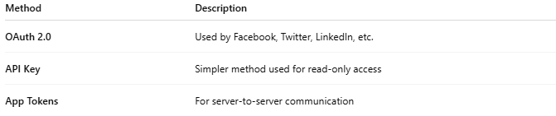

Method | Description
OAuth 2.0 | Used by Facebook, Twitter, LinkedIn, etc.
API Key | Simpler method used for read-only access
App Tokens | For server-to-server communication

💼 Use Cases
# Source: Chatgpt (GPT-5-Mini) at [1/19/2026]
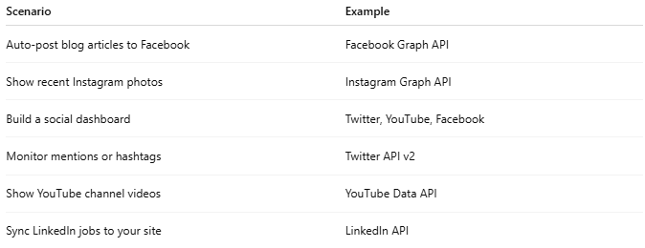

Scenario | Example
Auto-post blog articles to Facebook | Facebook Graph API
Show recent Instagram photos | Instagram Graph API
Build a social dashboard | Twitter, YouTube, Facebook
Monitor mentions or hashtags | Twitter API v2
Show YouTube channel videos | YouTube Data API
Sync LinkedIn jobs to your site | LinkedIn API

⚠️ Limitations & Notes
# Source: Chatgpt (GPT-5-Mini) at [1/19/2026]
- Most APIs require developer registration.
- User consent (OAuth) is needed for accessing private data.
- Many APIs have rate limits (e.g., 500 requests/hour).
- Business accounts are often needed for full access (e.g., Instagram Graph API).

